## **Introducing Tanh and ReLU activation functions**

What are the other alternatives to the Logistic function?

1. **tanh**
   1. The following figure illustrates the tanh function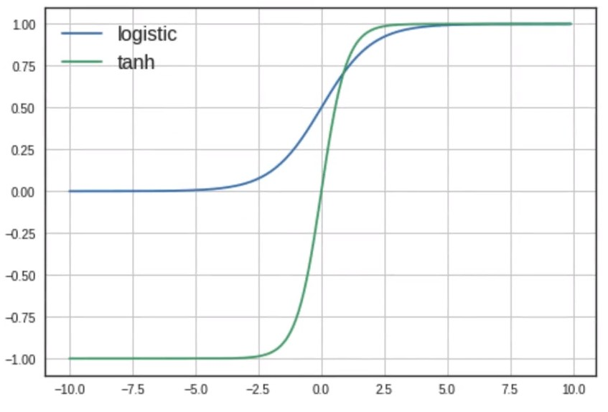
 $f(x) = \frac{e^{x}-e^{-x}}{e^{x} + e^{-x}}$

 $f'(x) = \frac{∂f(x)}{∂x} = (1 - (f(x{))}^{2})$

 2. The tanh function ranges from -1 to +1, whereas the logistic function ranges from 0 to 1
   3. It is a zere centered function.
   4. The function saturates at f(x) = -1 or 1, thus causing the gradients to vanish.
   5. tanh is computationally expensive because of ex
   6. However, it is still preferred over the logistic function
2. **ReLU**
   1. The following figure illustrates the ReLU function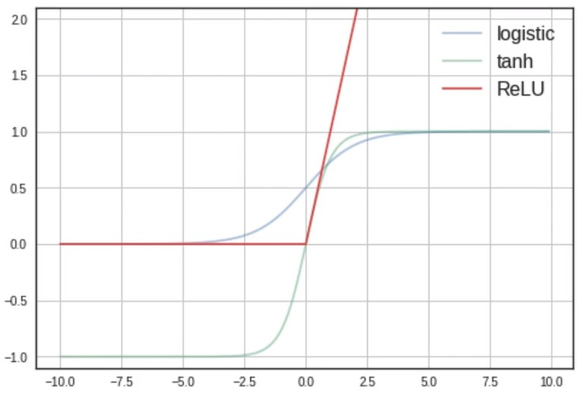
 $f(x) = max(0, x)$

 $f'(x) = \frac{∂f(x)}{∂x} =0 if x<0 | 1 if x>0$

 2. ReLU outputs the input value itself if it is positive, else it outputs zero, i.e. f(1) = 1, f(-1) = 0
   3. It does not saturate in the positive region
   4. It is not zero centered
   5. Easy to compute (no expensive ex)